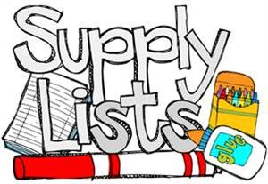

**Supply List for Students**

* small/pocket umbrella or a poncho/rain jacket that fits in your backpack
* #2 pencils
* black or blue-ink pens
* 8 folders—one for each subject and a homework folder
* wide-ruled loose leaf notebook paper packages
* colored pencils
* markers
* index cards
* erasers
* hand-held pencil sharpener
* pencil pouch
* composition book
* USB flash drive